Washington-Saratoga-Warren-Hamilton-Essex
Distance Learning Project

Student Handbook
2020-2021 School Year

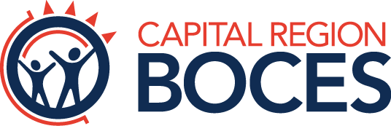

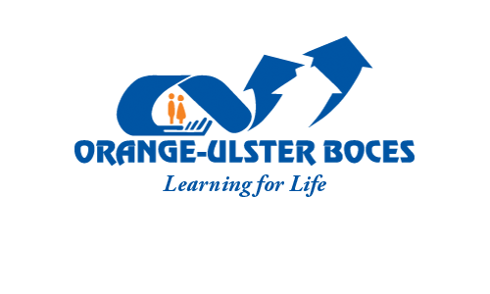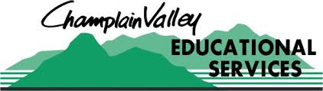

Rev. 08/04/20

Table of Contents

I. DISTANCE LEARNING PROJECT INTRODUCTION
Project Goal …............................................................…………………. 5
Project Description ...................................................…………………… 5
Distance Learning .......................................................…………………. 5
Project Participants .........................................................……………… 5
The Distance Learning Classroom ..........................................………… 5 – 6

II. STUDENT POLICY
Course Registration........................................................………............ 6
Student Orientation ...........................................................…………….. 6
Student Evaluation ............................................................…………….. 6
Student Grading ...............…................................................…………... 7
Student Record Keeping ...............................................……………..…. 7
Student Discipline Policy ..........................................……………………. 7 – 8

III. COURSE SCHEDULE ..............…................................................…...... 8

IV. CALENDAR ..............…................................................………….......... 8

V. CLASS CANCELLATIONS AND INTERRUPTIONS............................. 8

APPENDIX: Distance Learning Student Agreement Form

I. INTRODUCTION

- Project Goal - The primary goal of the WSWHE BOCES Distance Learning Network is to expand educational and vocational opportunities.

- Project Description - The WSWHE BOCES Distance Learning Network is a multi-way, fully interactive, full-motion video and audio system using fiber optic cable and telecommunications equipment to connect specifically designed classrooms in the participating school districts.

- Distance Learning - The WSWHE BOCES Distance Learning Network uses real time integrative full-motion video and telecommunications technology to enable a teacher and students in a distance learning classroom in one school to see, hear, and talk to students in comparably equipped classrooms in other schools in the network. The simultaneously interactive environment means that teacher and students remain in visual and verbal communication at all times during the class.

- Project Participants - Courses were first offered in the 1996-97 school year. Fifteen (15) districts are currently participating in the project:

Argyle (2 DL rooms) Hartford (2 DL rooms)
Cambridge Indian Lake
Corinth Johnsburg
Fort Ann Salem
Fort Edward Schuylerville (3 DL rooms)
Galway (2 DL rooms) Warrensburg
Granville (2 DL rooms) Whitehall
Hadley-Luzerne

Forty-four (44) additional sites in the Capital Region BOCES, Franklin-Essex-Hamilton BOCES, Hamilton-Fulton-Montgomery BOCES, and Questar III regions are also directly connected to the system, along with sites in the Champlain Valley Educational Services and Orange-Ulster BOCES regions.

E. The Distance Learning Classroom - The classroom in which the teacher is located is the host site. The classrooms to which a host site transmits are called the remote sites.

Each distance learning classroom is similarly equipped with two-way, fully interactive audio/video equipment. The equipment consists of:

- an overhead-mounted document camera to display visual material and serve as an “electronic chalkboard.”
- a camera focused on the teacher. In most rooms, this camera is in the front of the room.
- a camera in the front of the room focused on the students.
- microphones located throughout the room.
- a sufficient amount of diffused light to transmit video properly.

- The Distance Learning Classroom (continued)

- two displays (most often one projection system and one LCD flat panel display) in the front of the room for student and teacher viewing of each remote site and any material displayed by means of the document camera, computer, and interactive whiteboard panel.
- teacher station touch screen controls to select the camera to be active and to adjust the camera (pan, tilt, and zoom).
- a phone/copier/scanner to transmit hardcopy between sites (quizzes, homework, instructions, etc.) and to contact students individually through a phone call.

Equipment for new sites will be determined based on current research and the latest viable technology available. All sites will be completely interoperable.

II. STUDENT POLICY

Course Registration

- Guidance counselors in respective school districts will schedule students for courses on the WSWHE BOCES Distance Learning Network. Enrollment issues will be handled by the Instructional Planning Committee.

B. All students scheduled for distance learning courses must meet district prerequisites for participation. Students must sign, along with their parents or guardian(s), the Student Agreement Form before starting a distance learning class.

Student Orientation

All students scheduled for distance learning courses will be provided:

- an opportunity to visit the distance learning classroom before the course begins,

- a copy of the Distance Learning Student Handbook.

Student Evaluation

- Distance learning students are evaluated in accordance with the course description. The host site teacher will inform students of the evaluation methods and processes at the beginning of each course.

- The final examination schedule is coordinated through and disseminated by the administrative point of contact in each district.

- Students are to maintain satisfactory performance (see the Student Agreement Form in the appendix).

II. STUDENT POLICY (continued)

Student Grading

- All grades are the responsibility of the host site teacher. The teacher will submit grades in numerical form. The teacher ensures that grade reports are transmitted to the guidance department at the remote site schools on the dates stated in the official distance learning school calendar.

- Host teachers submit interim (five-week) reports to the guidance department at the remote sites on the date stated in the official distance learning calendar, using the official form of the sending school.

Student Record Keeping

- Student records for distance learning courses are kept by the host site teachers. This includes grades, attendance, and any other information deemed necessary.

- The supervising staff member at each site will take daily attendance in the distance learning classroom and report all absences to the appropriate authority, in accordance with school attendance procedures.

- The host site teacher will send all cumulative records to the administrative point of contact at the distance learning students’ respective schools at the conclusion of the course.

Student Discipline Policy

The success of the Distance Learning Program requires the cooperation and support of students. The following expectations must be understood and agreed upon by students and parents alike.

Students are expected to:

- follow all school rules, and those established by the host site teachers, including those rules specifically developed for the WSWHE BOCES Distance Learning Network,

- handle distance learning classroom equipment only if authorized to do so,

- sit within camera view at all times unless instructed by the teacher to do otherwise,

- attend conflicting local assemblies only when directly involved in presenting the assembly program,

- understand that their distance learning class(s) takes precedent over conflicting local extracurricular / co-curricular activities. If a student is to miss a class, it is the student’s responsibility to give the class teacher advance notice.

Inappropriate student behavior at the remote sites is handled by the site administrator (or designee). The supervising staff member at the remote site is responsible for communicating any discipline problem to the appropriate administrator.

Student Discipline Policy (continued)

In cases where rules are not followed, students will be subject to local procedures (e.g. removal from the course) administered by the teachers, site administrator(s) and/or others as designated.

III. COURSE SCHEDULE

IV. CALENDAR

The WSWHE BOCES Distance Learning Network calendar is designated as follows:

- The official distance learning calendar for each class is the host site calendar.

- The calendar includes the dates for end of marking periods and due dates for interim reports and grades, mid-term and final examination dates, and other procedural dates.

- Calendars will be exchanged between sites at the beginning of the school year.

V. CLASS CANCELLATIONS AND INTERRUPTIONS

- Classes are cancelled only for factors at the host sites such as equipment failure or snow days, or for scheduled events (e.g. early dismissals for conferences) appearing on the official distance learning calendar.

- Cancellations at remote sites are treated as days missed and the students are responsible for making up the work at the teacher’s discretion.

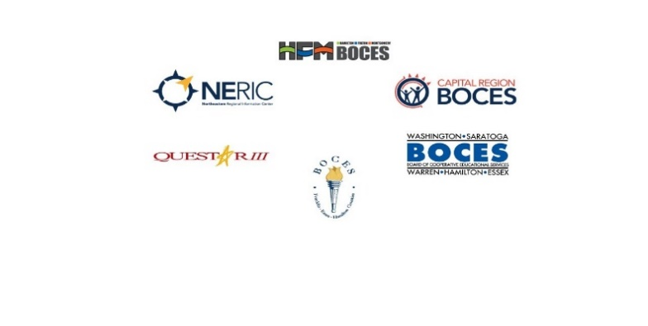

DISTANCE LEARNING (DL) STUDENT AGREEMENT FORM

The WSWHE BOCES Distance Learning Network represents an opportunity for students to take advantage of the latest technology and instructional techniques and to receive programs that might not normally be offered in this school. The program can only function with the cooperation of the students. Students enrolled in distance learning courses and their parents will enter into an agreement whereby the students will conduct themselves in such a manner as to ensure the optimum utilization of the program.

Please carefully read the information below and sign in the space provided to indicate your understanding of the rules and your agreement to abide by them.

As a student taking a course on the WSWHE BOCES Distance Learning Network, I understand that:

- Appropriate behavior is expected at all times. Insubordination (defined as anything that interferes with teaching or learning in the classroom) of any kind will not be tolerated.

- I will follow all school rules as outlined by my school’s code of conduct, and those established by the host-site teachers, including those rules specifically developed for the Saratoga-Adirondack Network. In particular:
  - Inappropriate language or gestures will not be tolerated.
  - I will treat school property with respect and I will be held responsible for intentional damage or destruction that I do to any property in the distance learning classroom.

- I will handle distance learning classroom equipment only if authorized to do so.

- I will sit within camera view at all times unless instructed by the teacher to do otherwise.

- I understand that, at times, classroom activities will be video recorded.

- Any electronic devices (including cell phones) must be turned off to avoid interference with the classroom audio system, unless otherwise authorized by my host-site teacher or local school district policies.

- I will only attend conflicting local school assemblies when I am directly involved in presenting the assembly program. In addition, my distance learning class takes precedent over conflicting extracurricular / co-curricular activities. I further understand that, if I must miss a class, advance notice to my teacher is my responsibility.

In cases where rules are not followed, students will be subject to a range of penalties from verbal warning to exclusion from the course.

I, ________________________________, understand the significance of the DL Program environment.
Student’s Name

I further understand the rules listed above and agree to adhere to them. I am making a commitment to complete the course for which I have registered.

__________________________________ ______________________________

Course Name(s) School year Signature of Student Date

______________________________
Signature of Parent(s) Date

Revised 7/2019

