
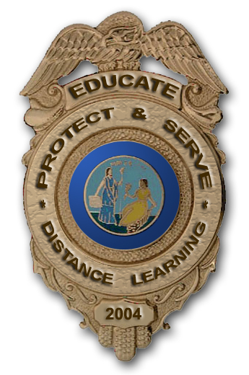

This course will address the basics of the legal system and
how we as citizens interact with that system on a daily basis.
Contracts, credit, criminal, and civil law are just a few of the
topics that will be investigated.
Topics May Include:
- Need For Law
- Basis of the Legal System
- Civil & Criminal Law
- Adult & Juvenile Courts
- Family & Consumer Law
- Causes & Consequences of Crime
- Individual Rights & Responsibilities
- Career Opportunities in the Legal System
Projects May Include:
- Mock Trial
- Ride-A-Long Programs
- Correctional Institution Visits, etc.

Our guidance office has more information on this course and the full range of courses offered through distance learning.
You can also log on to: http://DL.NERIC.ORG to find out more.

