Distance Learning Classroom

Mechanicville
Touch Panel User Guide

Model TPS 4500 (B)
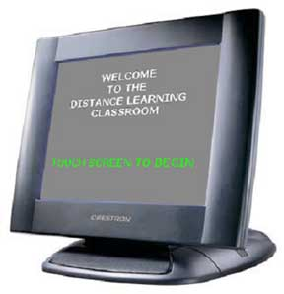

This manual contains information for Crestron color touch panels similar to the one in your room. If you have any difficulty following these instructions please contact the BOCES DL Coordination and Support Staff. rev. 10/7/04

Distance Learning Classroom
Touch Panel User Guide TPS-4500 (B)

Section Table of contents

Welcome Screen | 2
Session Type | 3
Teacher Camera Controls | 4-5
Student Camera Controls | 6
Play VCR Controls | 7
DVD Controls | 8
Optional Tuner Controls | 9
Computer & Auxiliary Controls | 10
Record VCR Controls | 11
Utilities Controls | 12
Volume Controls Important Note Regarding Echo | 13

Welcome Screen

The Welcome Screen is the first screen that you will see.

If your touch panel screen is black it is most likely in sleep mode.

Touch the face of the panel and this screen should appear.

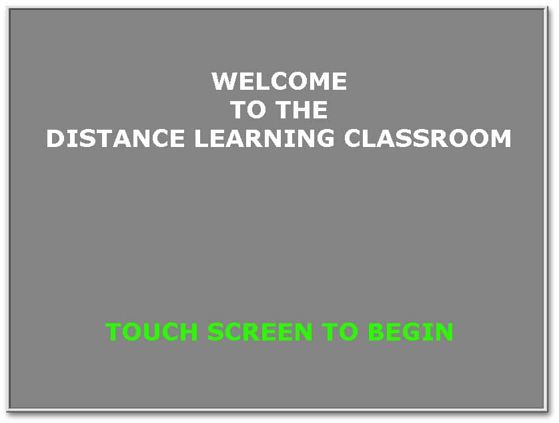

Touch the screen again to proceed.

Session Type

The screen below allows you to configure the room for a local presentation or a distance learning network session.

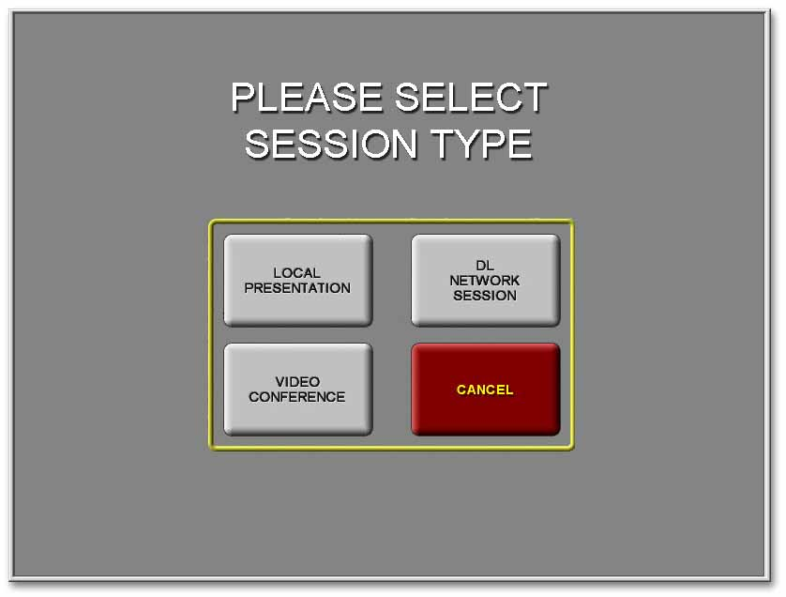

For a Distance Learning Class:

You must always select Network Session by touching that button on the screen.

Teacher Camera Controls

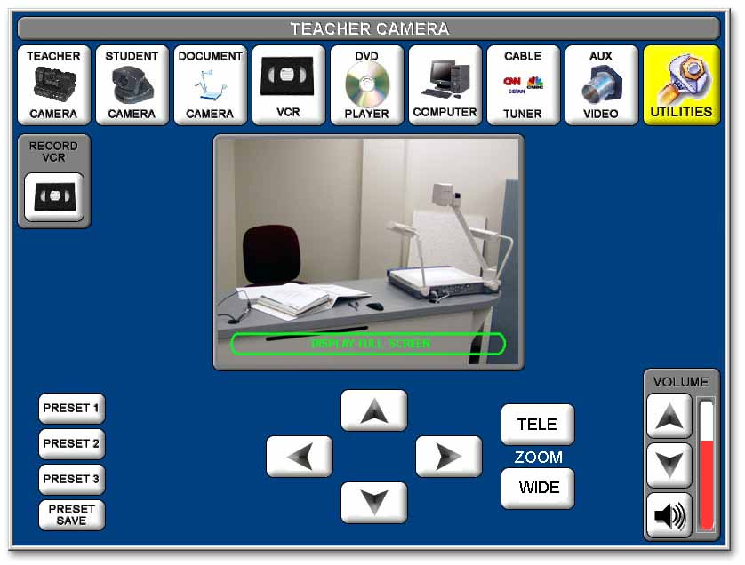The Teacher Camera Control screen (shown below) appears as the default screen in both session types.
On most screens the video shown in the center of the touch screen represents the transmitted video.
Touching the screen where it says “DISPLAY FULL SCREEN” will fill the touch screen with the video representation of your transmitted signal. Touching the expanded video will return it to normal.
The buttons across the top of the screen are similar to a tool bar and appear on most screens selected.

Touch the button for the equipment you want to control or the function you want to perform.
Teacher Camera Controls continued

Pan/Tilt Controls

Touch the triangles [ ] that point up, down, right, and left, to pan and tilt the Teacher Camera to any desired position.

Zoom Controls
Touch “ZOOM IN” or “ZOOM OUT” to adjust the camera view.

Volume Controls
Allow you to increase or decrease the overall volume of the received audio in your room.

Tool Bar Buttons
All other buttons will take you to screens indicated by the text.

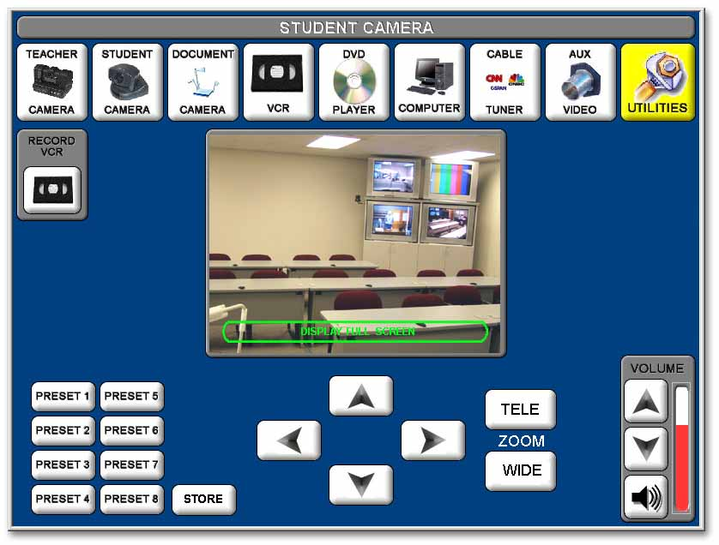
Student Camera Controls

Pan / Tilt / Zoom Controls
Operate these controls the same as you would for the Teacher Camera.

Preset Controls
Operate the Preset Controls the same as you would for the Teacher Camera.

Cover Shot
Is a special Preset that should be adjusted to a camera position that is just wide enough to allow all of the students to be seen in one shot.

Store
Is only used when establishing or changing presets. It will erase previously established presets. (For detailed information about establishing or changing camera position presets, see the Presets instructions beginning on page 12 of this section.)
Play VCR Control
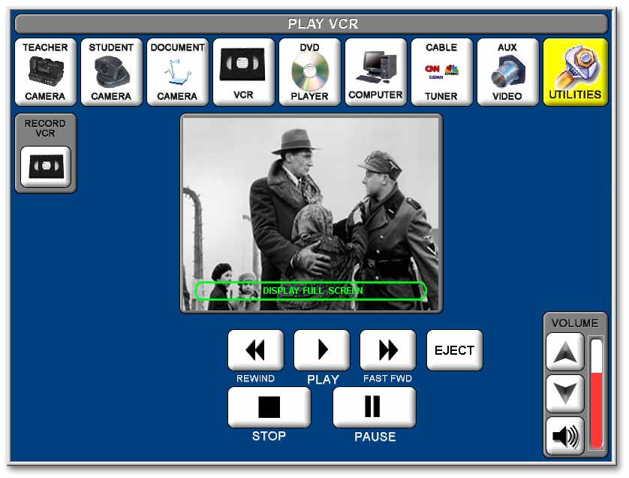
The Play VCR is a combination DVD/VCR and is the top unit of the two located in the teacher podium.
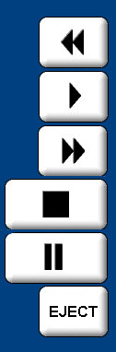
Video Tape Controls
Rewinds the videotape.

Plays the videotape.

Fast-forwards the videotape.

Stops the videotape.

Pauses the videotape.
Ejects the videotape.

VCR Room Volume Control
The Up and Down Triangle buttons control the level of volume that you hear in your own classroom.
Cable Tuner
Accesses the screen to control cable TV connected to the classroom equipment (where applicable - see next page).
DVD Control

The DVD is the combination DVD/VCR located uppermost in the teacher podium.
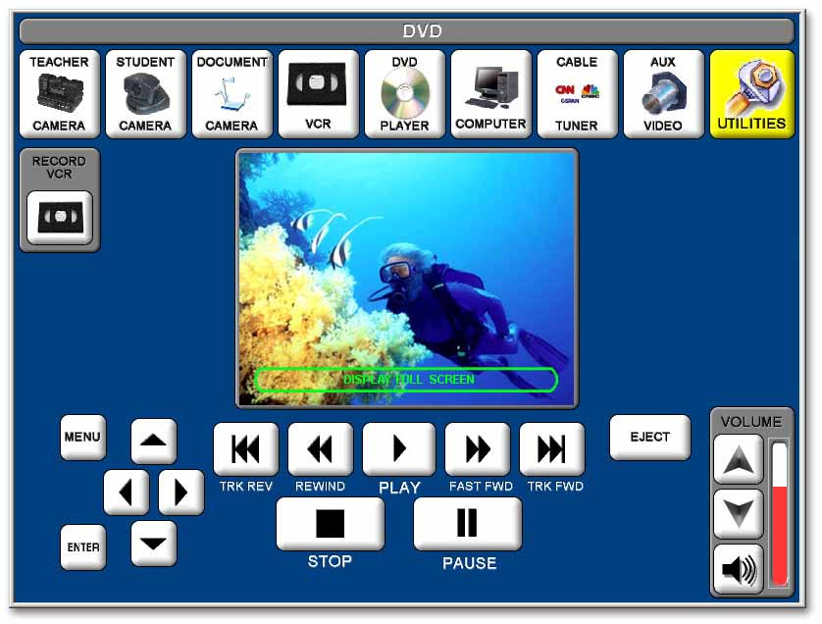

DVD Controls
The DVD controls are similar to the VCR controls. There are additional buttons for shuttling the track back (TRK REV) or forward (TRK FWD).

MENU Controls
There are controls at the bottom left of the screen that will allow you to access the DVD MENU.

Press MENU, then using the up, down, right and left buttons you can navigate the on-screen menu.

Press ENTER to select the MENU item you highlight.

DVD Room Volume Control
The Up and Down Triangle buttons control the level of volume that you hear in your own classroom.

Optional Tuner Controls

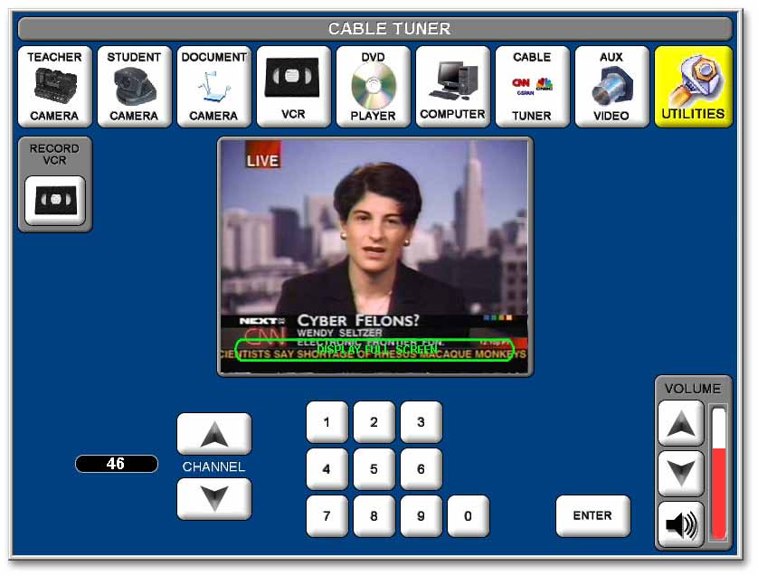

Tuner Controls

Controls are similar to remote controls for most TVs and VCRs.
The channel number is displayed in the oval to the left of the channel up/down control.

Computer and Auxiliary Controls

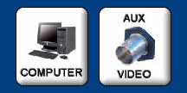

When you select the computer or an auxiliary video source (such as a camcorder or additional VCR or DVD player), you will be able to control some of the functions of that equipment from the touch screen.

Computer – Auxiliary Volume

If you have an auxiliary audio source input into the rack, or if you have the computer selected, you will be able to control the volume from those sources at these screens.

NOTE: If you excessively increase the volume levels, it may cause echo or other audio disturbances. (See page 11 for detailed information on volume control.)

If you adjust the output volume controls that are on the individual pieces of equipment (computer, camcorder, DVD, etc.), it will affect both the room volume and the transmitted audio level.

All other adjustments for the computer or auxiliary equipment should be made on the individual equipment.

Record VCR Controls

The Record VCR is the bottom of the two vcr units located in the teacher podium.

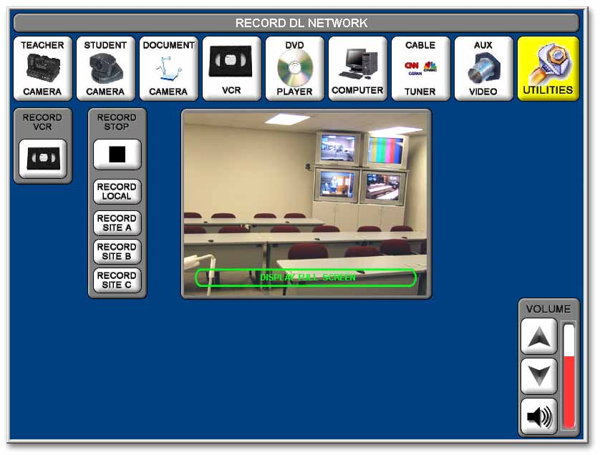
Site Recording Controls
Touch Local, Site A, Site B, or Site C to record the video from that particular site.

Recording will continue, even if you leave this screen, until you return to the Record VCR control screen and press Stop or your tape reaches the end.

Note: While you record only one video source at a time, you record all audio from all sites in the cluster onto the tape.

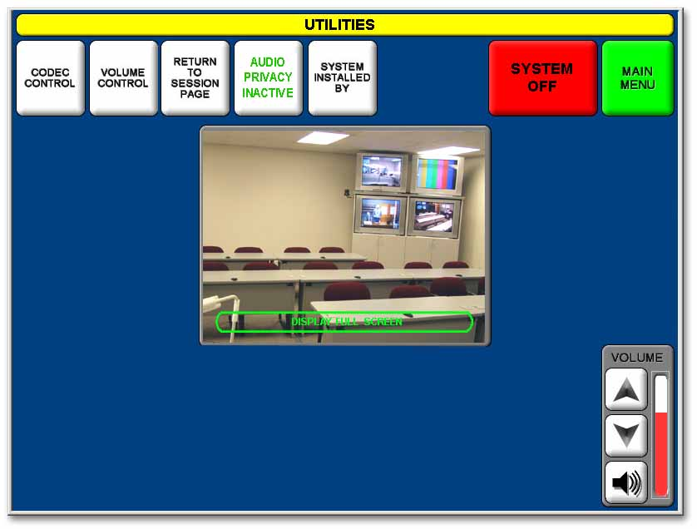
Utilities

CODEC CONTROL
Will take you to a screen where you can set up a videoconferencing session.
(Instruction on the videoconferencing capabilities of your room, which is different than “Dedicated Fiber Distance Learning”, will be provided in a separate training.)

Volume Control

Will take you to the volume control screen where you can adjust individual site volumes. See Important Note beginning on page 11.

Audio Privacy
Touching “AUDIO PRIVACY” will (depending on its position) either activate or inactivate all microphones in your room. You will still be able to hear remote sites, but they will not hear you. When activated, “AUDIO PRIVACY ACTIVATED” will flash on the touch panel screen.

Volume Control Screen
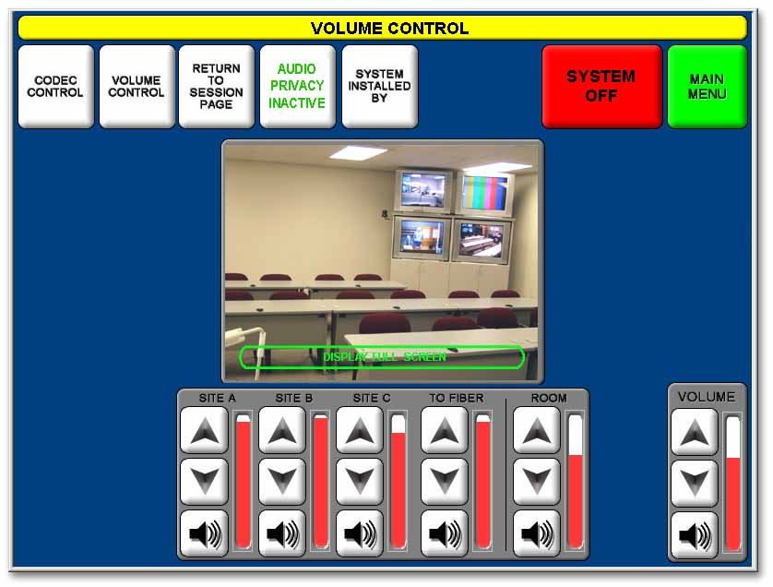

SITE VOLUMES
The incoming volume of each individual remote site can be adjusted with the controls under the appropriate label, SITE A, SITE B, or SITE C.
Adjustments are made with the [ ] up and down triangles.

TO FIBER
Allows you to increase the audio level that you transmit to other sites.

ROOM
Allows you to adjust the volume going to your room speakers’ amplifier.

IMPORTANT NOTE REGARDING AUDIO ECHO
A common cause of echo is the excessive increase in site audio levels in an attempt to compensate for an individual who is speaking very softly and/or leaning back from his/her microphone. The solution is to have the individual speak in a normal tone of voice and sit closer to the microphone.

If the individual is at a remote site that has individual microphone controls, you can request that the remote site increase only that microphone level. Please note that any adjustments you make to your volumes in your session may not work well in subsequent sessions.
If you have any trouble adjusting volume please contact the D.L. Help Desk.

